\

T3 Trips Tickets & Tours Centre

PLDT +63.34.4315678 Globe +63.9177043863

Email: [t3centre@yahoo.com](mailto:t3centre@yahoo.com) Website: [www.t3centre.com](http://www.t3centre.com/)



**PASEO DE ILOILO & BACOLOD FOR Ms. ANA MAY AND FRIENDS**

**OCTOBER 15-20, 2025**

**ITINERARY**

**Wednesday, 15 October 2025**

**AIRPORT PICK UP PR2141 (Mla - ILO) ETA 9:45AM \***

**CENTRAL ILOILO AND ONWARDS TO MIAGAO**

9:45 ETA ILOILO / PICK UP FROM AIRPORT

10:00 DEPART FOR CABATUAN

10:15 BALAY TABLEA TSOKOLATE METATE DEMO WITH LIGHT SNACKS

11:30 DEPART FOR CLARA FARM IN MAASIN OR AREVALO FOR SEADOOD LUNCH

12:00 LUNCH

1:30 START OF COUNTRYSIDE TOUR

2:00 SEAFDEC FISHWORLD

2:30 MIAGAO CHURCH

3:00 MIAGAO HABLON WEAVERS

4:00 BACK TO ILOILO

5:00 DINNER AT BREAKTHROUGH (IN CASE YOU DECIDE TO HAVE LUNCH AT CLARA FARM)

7:00 CHECK IN AT HOTEL

END OF DAY 1

BALAY TABLEA, CABATUAN – see how tsokolate metate is done. A metate is a slab of rock or volcanic stone that is hand carved and used throughout Latin America to grind cacao, corn, chiles, and many other ingredients. The metate that Ms. Catherine Villobos Taleon uses was handed down to her; this was used to make tsokolate by generations before her. Package Cost of 200/pax includes tsokolate aguada for everyone as welcome drinks, demo of how cacao is turned into tablea. Another round of hot choco in a small cup .. this time Tsokolate espesso with ibus (kakanin made of sticky rice, yummy) and with mangoes, if still in season. This is a hands-on experience that most of my guests love.

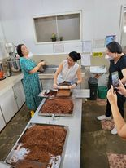 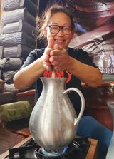 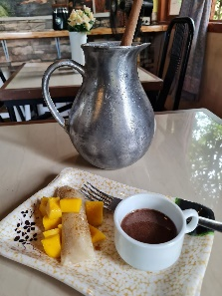 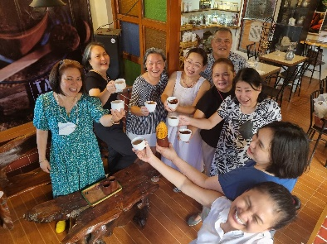

CLARA FARM at Maasin

Perhaps 10 minutes away from the Balay Tablea is a small farm run by a banker/entrepreneur / restaurant owner / organic farming practitioner young lady, Myka Perlas. Clara Farm is a 1-hectare Permaculture Demo Farm. Myka describes her place as *“Nestled amidst the bright green colors of sugarcane fields is our slow and sweet naturally maintained farm”.*

Would your family want to visit a farm?

She can whip up a good farm-to-table lunch. The cost would be around 350 per person.

These are some of my recent happy guests.

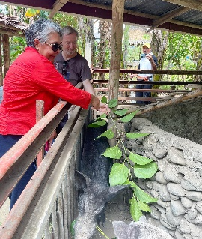 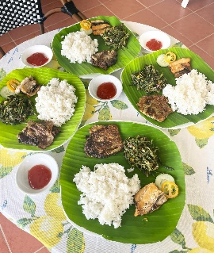 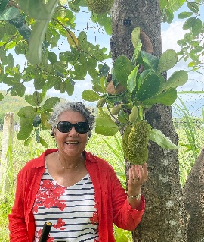

BAYI BAYI ALONG THE DIVERSION ROAD

From Pavia or Sta. Barbarbara, you can buy the good bayi bayi along the road. Will get some for your family.

Another good place to have lunch is BREAKTHROUGH OR TATOY’S at Villarica de Arevalo. Lunch by the beach … your choice, no introduction is needed. Either of the two is good. I will just have to get that pulot as some sort of dessert since that one I miss. Hahahah. Yes ... it is the place where you can eat the seafood you’re craving for.

We can’t go to the Iloilo City Proper Museums yet since this will fall on a Monday and all of the Museums are closed ... So, I suggest that we take the Southern Iloilo Tour.

SEAFDEC FISHWORLD

Kids can see the turtles that have been saved ... and what is interesting here are the *sabalo* and one is even 40 years old. Southeast Asian Fisheries Development Center Aquaculture Department in Tigbauan, Iloilo carries one of over 700 sabalo or mother bangus or milkfish breeders (though most of them are male), the biggest being almost 4 feet long and 119 kilograms in weight (as of last week since I was there).

Cool, right? Picture on the left is not mine. The right one is.

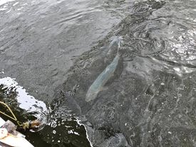

[SEAFDEC’s mother bangus prolific at 35 - VERA Files](https://verafiles.org/articles/seafdecs-mother-bangus-prolific-35)

For this afternoon leg, visit the Miag-ao Church - a fortress church included in the UNESCOs World Heritage List and the women hablon weavers of Miagao. Oh, they make UP sablay na hablon.

Trip back to Iloilo, if parents need to rest, they have like an hour to sleep while riding the coaster when we go back to the city. Like this … ? Oh, this group came from Las Islas de Gigantes with a 4-hour ride. Our guides are not that boring, I swear.

If time permits …

DISTRICT OF MOLO

Visit the ST. ANNE PARISH CHURCH in Molo, one of my favorite churches in Iloilo. We can have a brief look at the MOLO PLAZA, and the MOLO MANSION which is not really much of a mansion but for small districts like Molo, it is one of the pretty ones that survived the Japanese occupation --- or should I say survived the scorched Earth policy of the guerillas. Molo Mansion is presently owned by the Sys (as in SM) so they have turned it into a Kultura souvenir shop (though I can’t guarantee if they are all locally sourced, heheh).

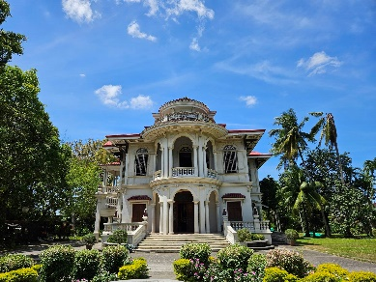 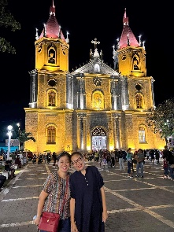

Molo may be a visited before dinner or the day after.

Meal Options

Lunch at Clara Farm (hopefully) there are local fruits that your family can enjoy on those dates).

Lunch or early dinner at Breakthrough or Tatoys. Dinner on pax account.

Dinner somewhere near your hotel or in the hotel in case parents are a bit tired.

Check in at your hotel.

**Thursday, 16 October 2025**

**ILOILO CITY / JARO**

8:00 PICK UP FROM HOTEL

8:30 NATIONAL MUSUEM WESTERN VISAYAS

CASA REAL/ CALLE REAL TOUR

PHILIPPINE ECONOMIC HISTORY MUSUEM

PHILIPPINE MARITIME MUSUEM

LUNCH .. BATCHOY?

1:30 RUNNING TOUR OF THE ANCESTRAL HOMES IN JARO

2:00 JARO CATHEDRAL

2:30 CASA MARIQUIT

3:30 UPV MACH (with 7 galleries)

DISTRICT OF MOLO IF THIS WAS NOT DONE ON DAY 1

PANCIT MOLO

6:00 DINNER ON PAX ACCOUNT

BACK TO THE HOTEL / REST

END OF DAY 2

Take the Calle Real Route and visit these museums.

By the way, almost all museums in Iloilo are a wow and FREE!

These are great examples of architectural adaptive reuse.

MUSEUM OF PHILIPPINE ECONOMIC HISTORY (the old Ynchausti y Sia Commercial Bldg.)

THE PHILIPPINEMARITIME HISTORY MUSUEM (old Customs House aka Aduana)

THE NATIONAL MUSUEM OF WESTERM VISAYAS (Old Provincial Jail)

UPV MACH - Museum of Arts and Culture (this one is near Molo)

.. and of course, while in Calle Real, you shouldn’t miss the QUEEN, the famous Roberto’s siopao.

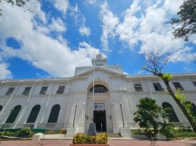 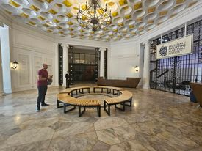

Running Tour of Bonifacio Drive, Lapaz, and the ancestral homes of Jaro.

Stop by: DEOCAMPOS, BISCOCHO HAUS, RGIES for some sampling ..

You might be interested in visiting these places that requires entrance fees:

Casa Mariquit - 50 pesos

Nelly Garden – 250, I think (kinda pricey .. but it is the grandest among all mansions. Well you may view it from afar so it is okay.

ILOMOCA – Iloilo Museum of Contemporary Arts – a three story art gallery and the works are the collection of only one person. Actually a cool place. 100 pesos, I think. There’s also the first brandy museum in the country at the ground level of ILOMOCA.

PANCIT MOLO? No problem. Although the gates of garage of where I used to take my friends are now closed to the public, we can still eat the same yummy pancit molo (na walang pancit) at a small resto nearby. Still in a caldero .. with the same yummy goodness that I have I have always loved. The place may not be that fancy but it speaks of what Ilonggos are; very humble and very simple. Kap Ising easily beats the rest of the pancit Molo makers in the district.

While in Molo, we then should not be afraid to try the famous street food that even my sosyal classmates would rave about. These balls never changed their texture and flavor through the years, JOANNE’S FISHBALLS!

AVANCENA BALAY NA BATO is one of my favorite places to bring my guests but now we have to number around 18 for them to prepare lunch or dinner. If there are others who have previously arranged with them, we could join. Separate tables, of course. Walk ins can have a round or two of espesso tsokolate, biscuits and pancit molo for 250 pesos just to see the place. Their ancestral home is more than a hundred years old. Here’s a secret: They order from Kap Ising that’s why their Pansit Molo is thaaat good.

A stone’s throw away is the VILLANUEVA SINAMAY HOUSE. We shall be going there not for Sinamay (similar to hablon) but for Corona Villanueva’s cookies. She uses locally sourced ingredients. My favorite are the chewy mango cookies.

**Friday, 17 October 2025**

**TRANSFER TO BACOLOD**

Choices for Iloilo – Bacolod Trips

Via OceanJet (nicer seats)

7:20 AM

11:00 AM

Via Weesam

6:30 AM

9:50 AM

6:00 Breakfast

8:00 Check out / Pick up

9:30 ETD ILOILO

11:00 ETA BACOLOD

BACOLOD CITY TOUR

SAN SEBASTIAN CATHEDRAL

11:30 PASS BY BAILON FOR ARTISANAL PIAYA SAMPLING

12:00 LUNCH BACOLOD CHICKEN INASAL (AIDA’S)

1:30 NVC SHOWROOM – Meet Ms. Millie Kilayko

PROVINCIAL CAPITOL AND LAGOON

ANP SHOWROOM

NEGROS FOREST PARK

NEGROS MUSUEM

DEPART FOR TALISAY

5:00 THE RUINS

6:00 BACK TO BACOLOD FOR THE **ELECTRIC MASSKARA**

DINNER ON PAX ACCOUNT (SUGGESTION: BOB’S)

CHECK IN

REST/ END OF DAY 3

PROVINCIAL CAPITOL AND LAGOON PLUS THE BACOLOD CITY GOVERNMENT CENTER

The Capitolyo is an imposing structure of Romanesque neo-classical architectural design, served as headquarters of the Japanese Imperial Army during World War II. It is presently the official seat of the Provincial Government of Negros Occidental. The Bacolod Government Center has a huge Bacolod signage ... that’s about it. Photo ops lang.

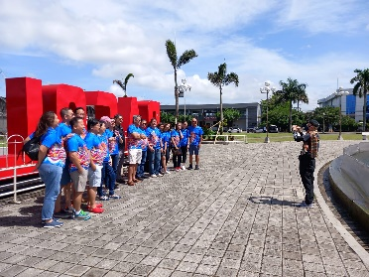

NEGROS FOREST PARK

“Our biodiversity conservation center is at the heart of our conservation efforts. Here, we take care in raising and breeding our native Negros wildlife in the hopes of reintroducing them back into our forests, while also educating the public about our amazing wild Negros.”

[Negros Forest Park | Talarak Foundation](https://www.talarak.org/negros-forest-park)

NVC SHOWROOM

Negrense Volunteers for Change (NVC) Foundation, Inc. was established in August 2010 in Bacolod City, Philippines by private citizens who believe that by pooling the energies, resources, talents, and skills of individuals, we can bring about a better future for Filipinos.

[About Us - NVC Foundation - A Philippine Charity (nvcfoundation-ph.org)](https://www.nvcfoundation-ph.org/about-us/)

If you plan to do some pasalubong shopping, I would rather bring you here ... proceeds go to the foundation. NVC’s Nespresso Art is something else ... from mask holders to earrings ... to full scale artworks on the wall. Ms. Millie Kilayko is the President, founder, and Mr. Yu’s good friend 😊.

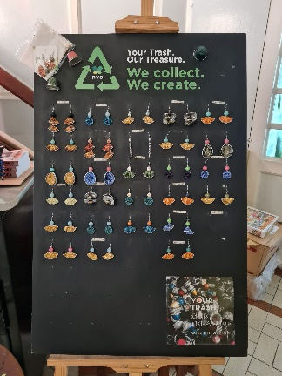

THE RUINS

One of Negros Occidental’s most iconic landmark. They have a super funny guide named Roger who takes amazing group photos.

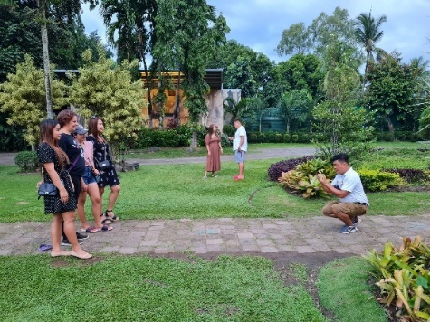

THE MUST-TRY LIST WHEN YOU’RE IN NEGROS OCCIDENTAL

Care for some sweets? Of course, there’s more than just sugar in Negros but what will your tour be without trying some? After all, Negros Occidental is the land of sweet surprises. Well, I’m a tad too literal here, hahaha.

Try the Halo-halo in Silay, just a hole in the wall kind of place but they make really good halo-halo, 15 concoctions to choose from.

Emma Lacson’s savory empanada and yummy pili squares, Silay’s lumpia, Virgie’s mango tarts, El Ideal’s guapple pie, Roli’s napoleones, Sharyn’s cansi, Felicia’s ensaymada, ... the list goes on and I don’t think you have the time nor the stomach to fill them all in. Aida’s Chicken barbeque (never leave Bacolod without trying one), don’t miss this one.

Speaking of Piayas, Bailon Piaya has been in existence for more than 20 years. Its unique and distinctive crunchy dough is neither flaky nor powdery and its inside is lightly coated with naturally sweet muscovado. In Negros, you will come across a lot of piayas but this one tops my list.

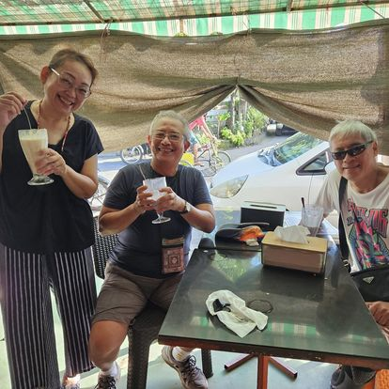

**Saturday, 18 October 2025**

9:00DEPART FOR SILAY, THE LITTLE PARIS OF NEGROS

RUNNING TOUR OF THE ANCESTRAL HOMES

SILAY PRO CATHEDRAL, CALLE LUNA HALO-HALO

MUST TRY: EL IDEAL’S GUAPPLE PIE, EMMA LACSON’S PILI SQUARES AND EMPANADA, MANANG SINDA’S FRESH LUMPIA

10:30 HOFILENA ANCESTRAL HOME (My favorite ancestral home in Silay)

11:30 BALAY NI TANA DICANG

TRY DEDI’S BITSO BITSO

12:30 LUNCH: TRY BACOLOD’S FAMOUS CANSI AT SHARYN’S

2:00 ORANGE PROJECT AT THE ART DISTRICT

4:00 **WATCH THE PARADE – SCHOOL CATEGORY**

DINNER ON PAX ACCOUNT.

SHOULD YOU WANT DESSERT: CALEA OR BOB’S CAFÉ

BACK TO THE HOTEL / REST

END OF DAY 4

CITY OF TALISAY

BALAY NI TANA DICANG

Among all Balay na Bato ancestral homes (there’s only a few Spanish period houses left standing), this one is the best maintained.

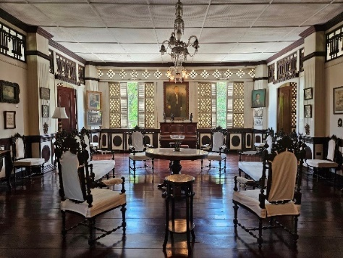 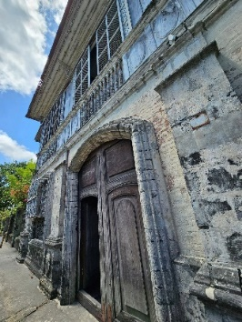 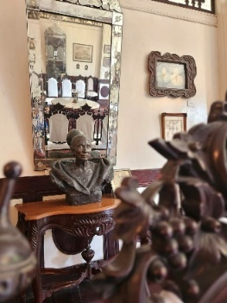

THE ORANGE PROJECT AT THE ART DISTRICT

The Art District showcases the talents of many young artists and the works other older Negros based artists are there too. The murals are quite “instagramable” (or whatever they call it).

Pics I took of some of my guests.

[Pandemic fuels creativity at Bacolod Art District - Digicast Negros](https://digicastnegros.com/pandemic-fuels-creativity-at-bacolod-art-district/)

[Orange Project | Bacolod CIty | Facebook](https://www.facebook.com/orangeprojectbcd/?locale=fr_FR)

**Sunday, 19 October 2025**

9:00DEPART FOR HINIGARAN

SAUMA

WIND CHIME MAKING

DEGUSTACION BY CHEF DON COLMENARES

**ANOTHER OPTION IS DEGUSTACION AT LANAI**

2:00 BACK TO BACOLOD

FRESHEN UP AT THE HOTEL

5:00 PROCEED TO THE **ARENA FOR THE BARANGAY COMPETITION**

Spend a creative afternoon at SAUMA, where Ms. MaryAnn Feria Colmenares, proprietor of Handmade Gallery and Artisana, and mother of Chef Don, leads a unique hands-on workshop on crafting wind chimes. Learn how to fine-tune your own chime to make it more melodious. You’ll get to bring home your handmade piece, of course. Experience Sauma and savor a meal by Chef Don Colmenares. Indulge in a curated tasting menu at **Sauma Degustación**, where Chef Don Colmenares crafts innovative dishes using only locally sourced ingredients from Negros. Each course is thoughtfully designed to highlight the unique flavors and textures of the region’s fresh produce and seasonal seafood. Nestled on his family’s rustic farm in Hinigaran, the restaurant offers a charming countryside atmosphere where you might spot roosters groomed for cockfighting and even enjoy a traditional carabao ride, making the dining experience both delicious and authentically Negrense.

Another option is:

LANAI BY FRESH START at MAY’S ORGANIC GARDEN

[Dec 5 Arc of Taste sampling at Lanai by Fresh... - Virna Ascalon Tan | Facebook](https://www.facebook.com/virna.a.tan/posts/pfbid02oBCbp8PHdBW77bbYPj3kTxdrkS47zKiopdWNFL6d6aEDinZMzaiyhYjyyyz6VgMgl)

[LANAI by FreshStart | Bacolod CIty | Facebook](https://www.facebook.com/LanaibyFreshStart)

[Bacolod’s Lanai is a chef’s playground, a farmer’s kitchen — The POST](https://thepost.ph/food/lanai-restaurant-bacolod/#google_vignette)

Experience a truly unique dining journey at **Lanai by Fresh Start**, Bacolod’s pioneering all-organic restaurant and a true “chef’s playground.” Founded by Ramon “Chin Chin” Uy Jr., Lanai champions hyperlocal, organic ingredients sourced within a 50-kilometer radius-mostly from the Uy family’s own farms and partner Slow Food communities. The menu is crafted entirely from scratch, with no shortcuts or artificial flavoring, showcasing the rich biodiversity of Negros Island’s land and sea.

**Monday, 20 October 2025**

**Check out / PR2134 (BCD-MNL) ETD 2:30 PM**

9:00 CHECK OUT

PASALUBONG SHOPPING

11:30 LUNCH AT STEPHEN’S BALAY PUTI

[Balay Puti Sizzles Back to Life (negrosseasonofculture.com)](https://www.negrosseasonofculture.com/2022/05/balay-puti-sizzles-back-to-life.html)

[(1) Stephen's at Balay Puti | Facebook](https://www.facebook.com/stephensatbalayputi/)

1:10 PROCEED TO THE AIRPORT

JUST 7 MINUTES AWAY FROM THE AIRPORT, MORE OR LESS 😊

1:20 ETA BACOLOD SILAY AIRPORT

2:30 ETD BCD VIA PR2134 (BCD-MNL) *

**\* ALL FLIGHTS PENDING AND NOT INCLUDED IN PACKAGE**

Take advantage now of the PAL seat sale, you may book your tickets on line (until August 30) or contact your suking ticketing agent.

**PACKAGE RATE PER GUEST BASED ON TWIN SHARING:**

|  |  |  |  |  |  |
| --- | --- | --- | --- | --- | --- |
| **6 PAX** | **7 PAX** | **8 PAX** | **9 PAX** | **16 PAX\*** | **Single supplement (ADD)** |
| P32,000.00 | P30,000.00 | P28,000.00 | P26,000.00 | P23,000.00 | P13,500.00 |

* Includes Degustación at Sauma in Hinigaran and wind chime making

|  |  |  |  |  |  |
| --- | --- | --- | --- | --- | --- |
| **6 PAX** | **7 PAX** | **8 PAX** | **9 PAX** | **16 PAX\*** | **Single supplement (ADD)** |
| P30,000.00 | P28,000.00 | P26,000.00 | P24,000.00 | P21,000.00 | P13,500.00 |

* Includes Degustación at Lanai (instead of Sauma) and will include Cacao Nursery visit

**\*For 16 guests, a coaster will be used.**

**CONDITIONS:**

* 50% payment to confirm booking. Full payment prior to arrival.
* 20% cancellation fee shall apply. Rebooking fees may apply.
* Rate subject to change if number of pax falls below minimum.
* No show or less than 3 days cancellation is subject to 100% forfeiture. No refunds.
* Rates are inclusive of government taxes.
* Kindly deposit to any of the bank accounts and email deposit slip copy to [t3centre@yahoo.com](mailto:t3centre@yahoo.com).

Account Name: T3 Trips Tickets and Tours Centre

* + PNB CA# 307970002244
  + BDO SA# 010490071716